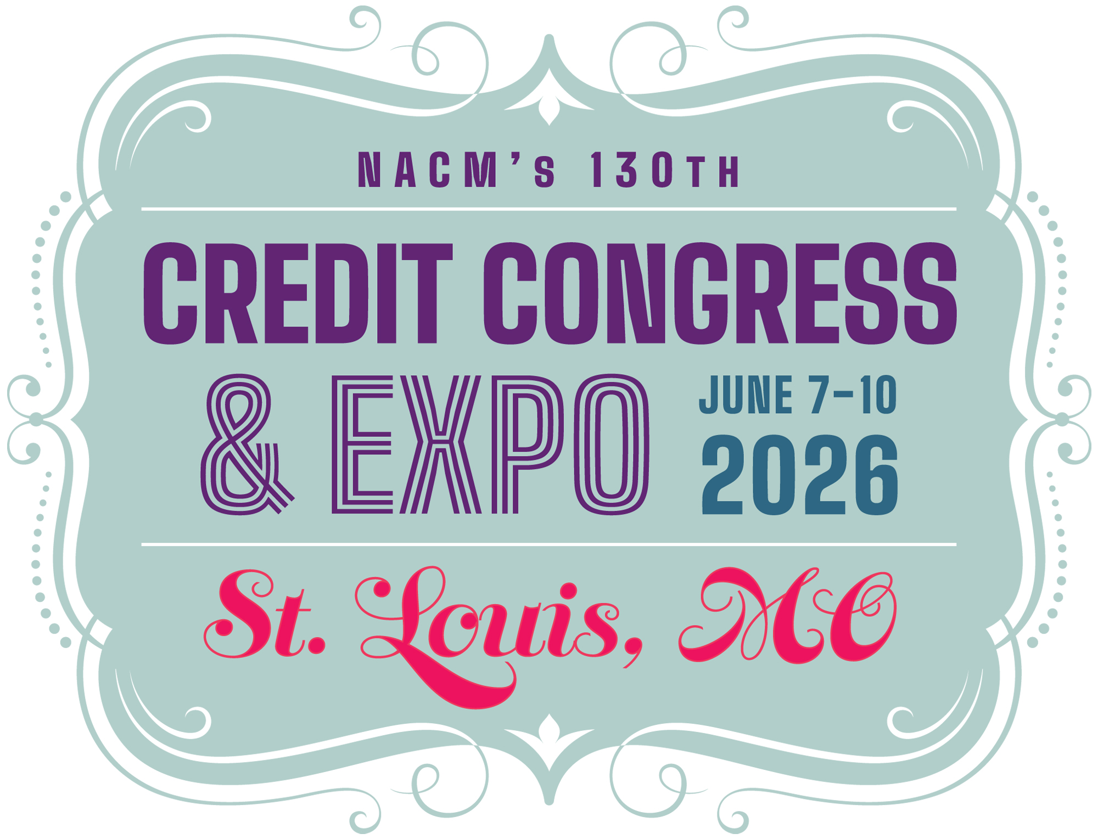
2026 NACM Credit Congress
Full Delegate Registration Form
Return form & payment to: NACM Credit Congress, 8840 Columbia 100 Parkway, Columbia, MD 21045
Address questions to: NACM Meetings Department / 410-740-5560 / conventions_info@nacm.org

 Delegate Information
First Name or Nickname (for badge)
Full Name for Badge
(include professional designation)
Title
Company
(please provide complete name)
Mailing Address
(please include mail stop, floor, etc.)
City, State/Province, Zip/Postal Code
Country | My country of citizenship requires GDPR compliance.
Office/direct Phone Number
Cell Number | For emergency notices and limited text updates or important conference info.
E-mail Address

Your e-mail address is used to communicate with you. By providing this information to NACM, you are giving your written permission
to receive news updates and announcements regarding events, special offers and other information. You may opt out at any time.

Your Local NACM Affiliated Association (ex.–NACM Southwest):
Describe any special needs, such as dietary or wheelchair access:
Please indicate your company’s primary industry:
Optional Demographic Information
Age
Gender
Highest Level of Education Completed
Years Working in Credit
Generation You Most Identify With
Ethnicity/Race
Annual Salary

2026 NACM Credit Congress Registration Form - Page 1 of 3

 | Early Bird  12/5/25 | Advance  12/6/25 to 2/20/26 | Regular  after 2/20/26 | Total
Member * | $879 | $999 | $1,129
Non-member * | $1,079 | $1,179 | $1,289
Service Provider * | $1,399 | $1,499 | $1,599
First-time Attendee - Come with a Colleague **  (provide details at the bottom of this form) | $299 | $349 | $399
Spouse/Guest *  (provide details at the bottom of this form) | $499 | $549 | $599
 Conference Rates & Optional Event Costs

Fees for the following are in addition to the registration fee. | Quantity | Rate | Sub-totals
Optional Educational Sessions and Luncheons:
Peer Learning Lab Bundle (Tues, June 9 & Wed, June 10) | $99 Savings with Bundle | $399 | $
Cross-Functional Collaboration Learning Lab (Full day Tues, June 9) |  | $249 | $
Succession Planning Learning Lab (Full day Wed, June 10) |  | $249 | $
Financial Statement Analysis 2 Certificate Course (Sat thru Wed) |  | $429 | $
St. Louis Highlights Experience Tour (Sun, June 7) |  | $99 | $
CBA Exam Review Session (Sun, June 7) |  | $199 | $
CBF Exam Review Session (Sun, June 7) |  | $199 | $
CCE Exam Review (Sun, June 7 - includes box lunch) |  | $249 | $
CFDD Luncheon (Wed, June 10) |  | $89 | $
Additional Closing Night Event Ticket  (1 ticket included with Full Delegate registration) |  | $199 | $
I am proud to support the NACM Scholarship Foundation. | $10 $25 $50  $100 |  | $
I am proud to support the CFDD Scholarship Fund. | $10 $25 $50  $100 |  | $
Facilities Usage Fee ~ Applicable only if you are not staying at one of our conference hotels. |  | $250 | $
Total (required for processing): NACM Tax ID# 52-1972771) |  |  | $
Registration Payment Policy - All conference delegates are required to submit full payment of the registration fee to secure their participation and rate category. Failure to make payment in full within 14 days of registration date will result in the cancellation of your registration.

2026 NACM Credit Congress Registration Form - Page 2 of 3

 Payment Information My check is enclosed payable to NACM Credit Congress.
Both the form and payment must be received for the registration to be processed. Fees may be paid with a check with this form or credit card by registering online.

Refund & Cancellation Policy for Credit Congress - NACM understands that unfortunate circumstances may sometimes affect your ability to attend an event. Should a request for a refund be necessary, please submit your request to the NACM Meetings Department in writing. For written requests received on or before April 10, 2026, full registration fees will be refunded, less a $75 processing fee. Between April 11, 2026 to April 17, 2026, 50% of the registration fee (including optional activities/educational sessions) will be refunded. Due to the financial obligations incurred by the NACM Credit Congress, NO REFUNDS OR CREDITS are possible for cancellations received after April 17, 2026; however, replacements may be made at any time (First-time Attendee replacements must be another eligible First-time Attendee).

Facilities Usage Fee - We urge you to make your hotel reservation at one of our three official conference hotels for NACM to maximize its meeting space, room block and help keep negotiated room rates as low as possible. The guest room block and group rate negotiated with the hotels includes costs to provide us with the large quantity of meeting spaces we require for the meeting. If we do not occupy a sufficient amount of guest rooms throughout the conference, we will incur penalties and additional costs. Therefore, we strongly urge all meeting participants to stay in the conference hotels. Consequently, guests not staying at one of the official hotels during the conference will be charged a Facilities Usage Fee, a flat fee of $250, to offset penalties and fees. Please note: If your residential address is in St. Louis, Missouri, you are exempt from the Facilities Usage Fee stated above.
 Additional Information for First-time Attendee or Spouse/guest
If you are registering a First-time Attendee or a spouse/guest, complete the appropriate section below.

Required Spouse/Guest Information (may not be a colleague)
First Name or Nickname (for badge)
Full Name for Badge
City, State/Province
Cell Number | For emergency notices, limited text updates or important conference info.
E-mail Address

Required First-time Attendee – Come w/ a Colleague Information (colleague accompanying the delegate registrant, paying together)
First Name or Nickname (for badge)
Full Name for Badge (include designations)
Title
Company (provide complete name)
Mailing Address (include mail stop, floor)
City, State/Province, Zip/Postal Code
Country | My country of citizenship requires GDPR compliance.
Office/direct Phone Number
Cell Number | For emergency notices, limited text updates or important conference info.
E-mail Address

First-time Attendee – Come with a Colleague - This special offer is for credit practitioners who have never attended Credit Congress and who will attend with a member or nonmember full delegate from the same company. Both delegates must have an individual room reservation at one of our three official hotels (see housing page) during the conference. Housing will be verified through our housing block. Offer is not valid with the Teams, Service Provider or Guest rates and cannot be combined with other offers, discounts or scholarships. Only one first-time attendee registration is permitted per each full delegate registration. Should the full delegate cancel, the first-time attendee will replace the full delegate registration at that rate. Should the new attendee cancel, the registration fee is nonrefundable.

2026 NACM Credit Congress Registration Form - Page 3 of 3

