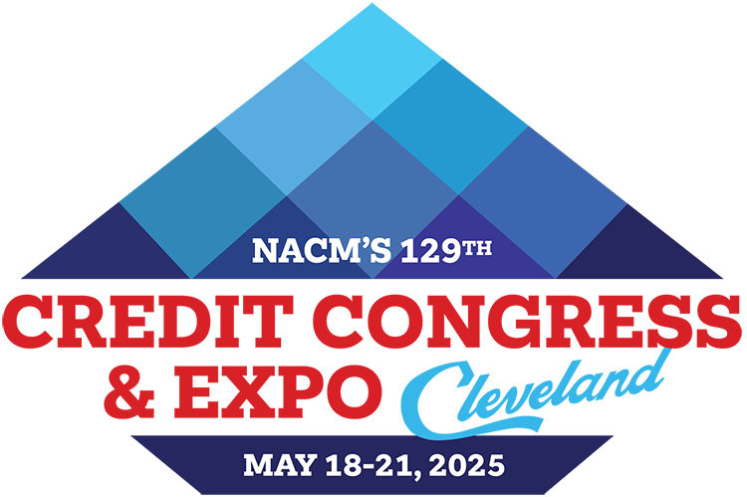
2025 NACM Credit Congress
Full Delegate Team Registration Form
Return form & payment to: Josh Tillman at josht@nacm.org
Address questions to: NACM Meetings Department / 410-740-5560 / conventions_info@nacm.org

Delegate Information
First Name or Nickname (for badge)
Full Name for Badge
(include professional designation)
Title
Company
(please provide complete name)
Mailing Address
(please include mail stop, floor, etc.)
City, State/Province, Zip/Postal Code
Country | My country of citizenship requires GDPR compliance.
Office/direct Phone Number
Cell Number | For emergency notices and limited text updates or important conference info.
E-mail Address

Your e-mail address is used to communicate with you. By providing this information to NACM, you are giving your written permission to receive news updates and announcements regarding events, special offers and other information. You may opt out at any time.

Payment Information
Both the form and payment must be received for the registration to be processed in full. Fees may be paid with a check with this form or credit card online after submitting the form electronically.

Check enclosed payable to NACM Credit Congress
OR
Please send me a web link to pay by credit card to complete my registration

Please review the Refund & Cancellation Policies on page 2 before completing this form.
Team Discount Rates
Team rates* are valid for 5 or more people from the same company, registering the same day. Prices are per person.

 | Early Bird - By 12/6/24 | Advance – After 12/7/24 | Regular - After 2/21/25
Team Rate | $799 | $929 | $989

Delegate Name, E-mail, Cell # and  Address, if different from primary contact | Rate | Optional Event Registrations  (Extra fee required for each) | Sub-totals
1.  My country of citizenship requires GDPR compliance. |  |  | $
2.  My country of citizenship requires GDPR compliance. |  |  | $
3.  My country of citizenship requires GDPR compliance. |  |  | $
4.  My country of citizenship requires GDPR compliance. |  |  | $
5.  My country of citizenship requires GDPR compliance. |  |  | $
6.  My country of citizenship requires GDPR compliance. |  |  | $
7.  My country of citizenship requires GDPR compliance. |  |  | $
Total $

Special Note:
If any of the delegates above require special accommodations or needs due to a medical condition or disability, please immediately have them direct a request to the NACM Meetings Department at conventions_info@nacm.org. If the cell number is provided, please note that the person agrees to receive emergency notices and limited text updates or important conference information.

Refund & Cancellation Policy for Credit Congress - NACM understands that unfortunate circumstances may sometimes affect your ability to attend an event. Should a request for a refund be necessary, please submit your request to the NACM Meetings Department in writing. For written requests received on or before March 21, 2025, full registration fees will be refunded, less a $75 processing fee. Between March 22, 2025 to March 28, 2025, 50% of the registration fee will be refunded. Due to the financial obligations incurred by the NACM Credit Congress, NO REFUNDS OR CREDITS are possible for cancellations received after March 28, 2025; however, replacements may be made at any time.

Facilities Usage Fee - We urge you to make your hotel reservation at one of our three official conference hotels for NACM to maximize its meeting space, room block and help keep negotiated room rates as low as possible. The guest room block and group rate negotiated with the hotels includes costs to provide us with the large quantity of meeting spaces we require for the meeting. If we do not occupy a sufficient amount of guest rooms throughout the conference, we will incur penalties and additional costs. Therefore, we urge all meeting participants to stay in the host hotels. Consequently, guests not staying at one of the official host hotels during the conference will be charged a Facilities Usage Fee, a flat fee of $250, to offset penalties and fees. Please note: If your residential address is in Cleveland, Ohio, you are exempt from the Facilities Usage Fee stated above.

2025 NACM Credit Congress Registration Form / Team - Page 2 of 2

